3.8 Maxima and Minima of Functions of Two Variables

Definition:
- A function of two variables has a local maximum at if when is near . The number is called a local maximum value or simply a local maximum.

- A function of two variables has a local minimum at if when is near . The number is called a local minimum value or simply a local minimum.

Note: We can make the notion of “near” precise by saying: “there exists some such that for every in the disk centered at of radius , .”

Note: Local maxes/mins are z values!

Remark: If we replace the words “when is near ” in the above definitions with “for all ” then we obtain the definition of absolute maximum and absolute minimum respectively, and we say has an absolute maximum at and has an absolute minimum at .

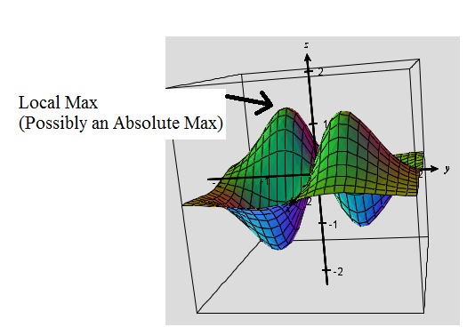
Ex: In the picture below a local max is identified. We cannot determine if it is a global max because it could be exceeded in a part of the graph that we cannot see.

Theorem: If a function of two variables has a local maximum or minimum at and the first-order partial derivatives of exist there, then and .

Proof: The proof is fairly straightforward; however, it is not included in the textbook.

Definition: A point is called a critical point of if and or if one of these partial derivatives does not exist.

Note: Critical points are where local minima/maxima MAY occur.

Example 1: Find all the critical points of the function .

We note that and . Since both of these partials are defined for all of , the only critical point(s) will be those that make both first partials equal to zero. When we solve the system , we discover that the only critical point is (1,3).

We will now go over a very useful test for determining whether a critical point is the location a local maximum or minimum.

Theorem (Second Derivatives Test):
Suppose the second partial derivatives of f are continuous on a disk with center , and suppose that and . Let . Then,
- If and , then is a local minimum.
- If and , then is a local maximum.
- If , then is not a local maximum or local minimum. We say that is a saddle point of .
- If , the test is inconclusive (i.e. it gives no information).

Proof: The proof is beyond the scope of this course. The key to proving this result is generalizing the notion of the second derivative test from calculus one.

Note: Results 1 and 2 are fairly easy to remember if one recalls the second derivative test from calculus 1. Also, it can be useful to remember D by the following determinant: . In higher level mathematics (namely advanced real analysis) one learns that this is the determinate of the Hessian of f. Hessians appear in Taylor expansions of multivariable functions.

Example 2: Find the local minimum and maximum value(s) and any saddle points of the function .

We wish to apply the second derivatives test. We note that and .
To find all possible critical points we must solve the system: .
The first equation implies that . If we substitute this result into the second equation we obtain:

This means that x is equal to 0, 1, or -1. Now, if we use the fact that , we see that the critical points are , , and .
We will use the second derivatives test on each of these critical points.
We note that , , and .
This means that . So, by the second derivatives test, we know that is a saddle point.

Also, and . So, by the second derivatives test is a local minimum.

Also, and . So, by the second derivatives test, is a local minimum.

A picture of the surface determined by is below and one can see the local minimums and saddle point:

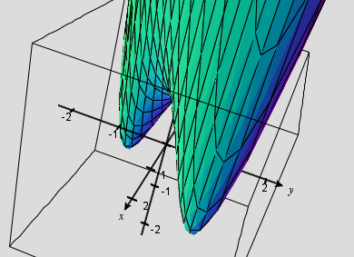

Note: Language in the above example is very important. In particular, it is proper to say that there is a saddle point at (0,0). It is also proper to say that there is a local minimum of -1 at (1,1), or there is a local minimum of -1at (-1,-1). It would NOT be correct to say that there is a local minimum of (1,1).

Example 3: Consider the function . Show that (0,0) is a critical point of f . Then, show that the second derivatives test is inconclusive in classifying (0,0).

We note that and .
We note that and . So, (0,0) is indeed a critical point.

In order to show that the second derivatives test is inconclusive in classifying , we must show that . We note that , , and . So we do indeed have that .

This means that at we could have a local min or max, or (0,0) could be a saddle point. That is, the second derivatives test gives us no information.

Note: With a fairly sophisticated argument it is possible to prove that there is not a local max nor a local min at (0,0). This argument makes no use of the second derivatives test.
We now move to discussing absolute extrema.

Definition (intuitive): A closed set in is one that contains all of its boundary points.

Note: For now, we will think of “boundary” in the intuitive sense. It is possible however, to give a mathematically rigorous definition of boundary point.

Ex: Based upon the above definition is a closed set, and is not a closed set.
Not
Closed
Closed

Definition: A bounded set in is one that is contained within some disk.

Theorem (Extreme Value Theorem for Functions of Two Variables):
If is continuous on a closed, bounded set D in , then attains an absolute maximum value and an absolute minimum value at some points and in D.

Proof: Beyond the scope of this course. This theorem is often proven in Real Analysis or General Topology.

Steps for Finding the Absolute Max or Min on a Closed Bounded Set:
- Confirm that is continuous.
- Find the values of at the critical points of in D.
- Find the extreme values of on the boundary of D.
- The largest of these values is the absolute maximum of on D. The smallest of these values is the absolute minimum of on D.

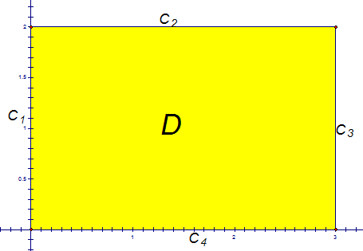
Example 4: Find the absolute maximum and minimum values of the function on the rectangle . Also, state where the absolute maximum and minimum values occur.

First, we will draw a picture of the set D. We easily see that D is closed and bounded. So, we are able to apply the above three step procedure.

For step 2, we need to find the critical points of in D.
We note that and .
To find the critical points we need to solve the system: . The second of these equations implies that If we substitute this result into the first equation we obtain . So is a critical point of and it is indeed in D. This means that is a candidate for the absolute max/min value of on D.

For step 3 we must analyze along each of the straight boundary segments of D (the boundary segments are labeled in the above picture).

Along the segment the function becomes where . Since this function is increasing, its extreme values are and .

Along the segment the function becomes where . We know that the function is a parabola that opens upward with vertex . Thus, along this segment the extreme values are and .

Along the segment the function becomes where . Since this function is decreasing, its extreme values are and .

Along the segment the function becomes where . We know that the function is a parabola that opens upward with vertex . Thus, along this segment the extreme values are and .

For step 4, we look at all the candidates for absolute min/max from steps 1 and 2, and we discover that the absolute maximum value of on D is and it occurs at . Also the absolute minimum value of on D is 0 and it occurs at (2,2) and (0,0).

